Lab 3 : Multi-Agent Collaboration (Supervisor Pattern)

Table of Contents
Table of Contents 2
Introduction 3
Learning Objectives 3
Prerequisites 3
Part 1 — Creating a Specialized Sub-Agent (HR) 4
Step 1 — Create the HR Agent 4
Step 2 — Create an Alias (Required for Collaboration) 6
Part 2 — Preparing the IT Ops Sub-Agent 9
Part 3 — Architecting the Supervisor Agent 9
Step 1 — Create the Supervisor 9
Step 2 — Add the Collaborators (Sub-agents) 11
Part 4 — Testing the Orchestration Routing 16
Test 1: Routing to HR 16
Test 2: Routing to IT 17
Knowledge Check 19
Conclusion 19

Introduction
As generative AI use cases expand across an enterprise, developers often try to pack dozens of tools, knowledge bases, and instructions into a single, monolithic agent. This "single-agent pattern" scales poorly: the prompt becomes too large, token costs skyrocket, and the LLM becomes confused, leading to tool-selection hallucinations.
The solution is Multi-Agent Collaboration. Using a Supervisor/Sub-agent architecture, you can create a lightweight Supervisor agent that acts as a router. When a user asks a question, the Supervisor evaluates the intent and hands the task off to a specialized, highly focused sub-agent (e.g., an HR Agent or an IT Ops Agent).
In this lab, you will create a specialized HR sub-agent, prepare your existing IT Ops agent, and build a Supervisor to orchestrate them.

Learning Objectives
Upon completing this lab, you will be able to:
- Explain the limitations of monolithic agents and the benefits of multi-agent architectures.
- Prepare Amazon Bedrock Agents to act as sub-agents by creating immutable Aliases.
- Architect a Supervisor Agent and attach sub-agents using the Collaborator feature.
- Trace the routing logic to verify the Supervisor correctly delegates tasks.

Prerequisites
Before starting, ensure you have:
- Administrator or PowerUser access to the AWS Management Console.
- An existing EnterpriseOpsAgent from previous labs. (Note: If you deleted it, quickly create a new Agent named EnterpriseOpsAgent, select Claude Haiku 3 or 4.5, give it the instruction "You are an IT Support Agent," and click Save).

Part 1 — Creating a Specialized Sub-Agent (HR)
To demonstrate routing, our Supervisor needs at least two distinct sub-agents to choose from. Let's create a mock Human Resources agent.

Step 1 — Create the HR Agent
- Navigate to the Amazon Bedrock console.
- In the left navigation pane under Build, click Agents.
- Click Create Agent.
- Agent name: HRBenefitsAgent
- Description: Handles employee benefits, payroll, and time-off requests.
- Click Create.
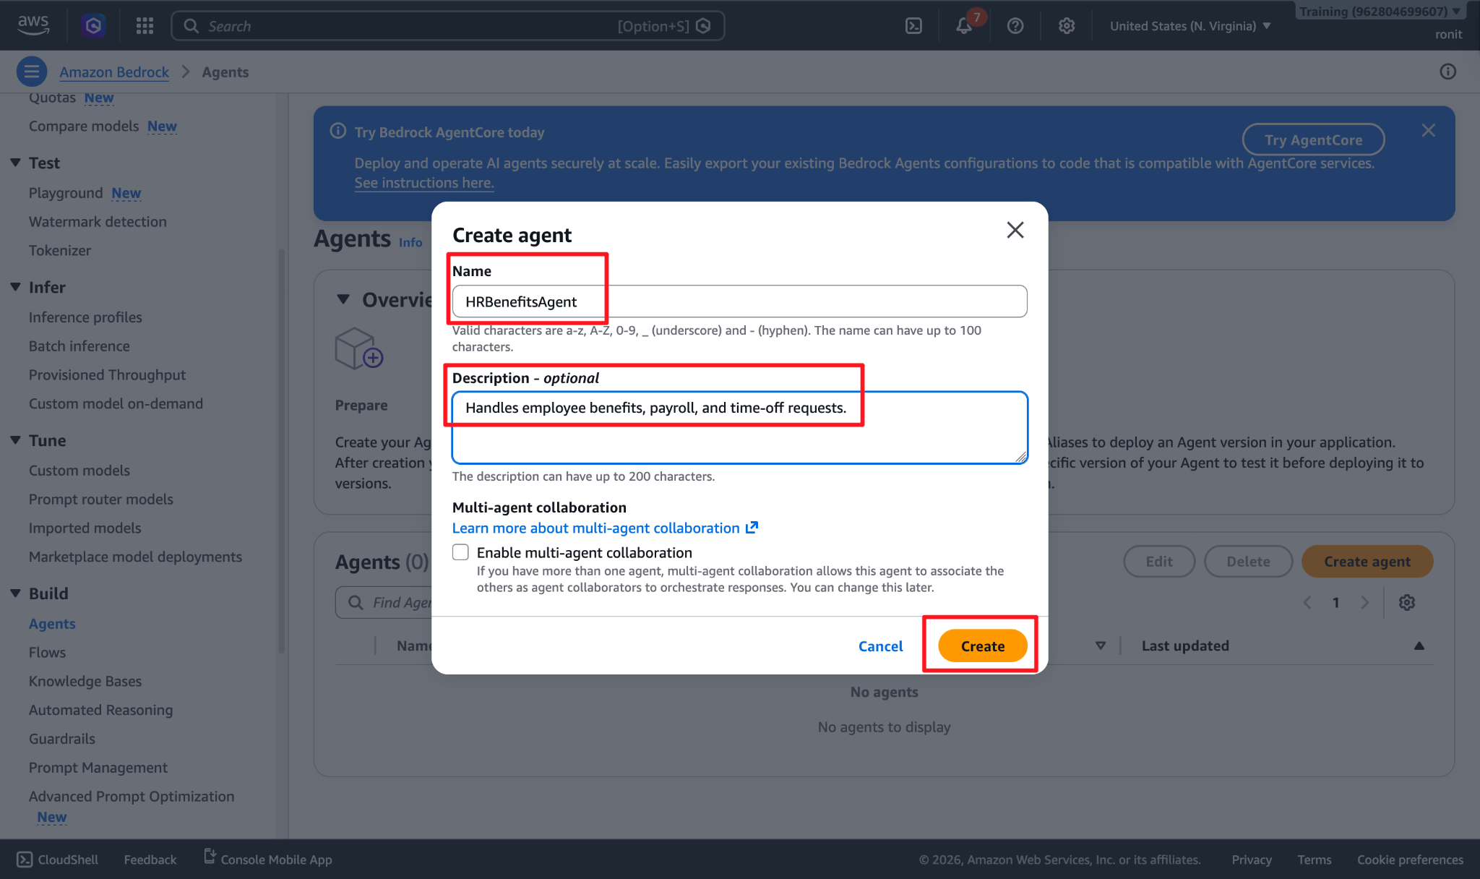
- Under Agent resource role, select Create and use a new service role.
- Under Select model, select Amazon Nova Pro or Claude 3.5 Haiku.
- Under Instructions for the Agent, paste the following: You are an HR Benefits Specialist. You assist employees with questions regarding their healthcare, payroll, and PTO (Paid Time Off). You are polite, empathetic, and strict about confidentiality.
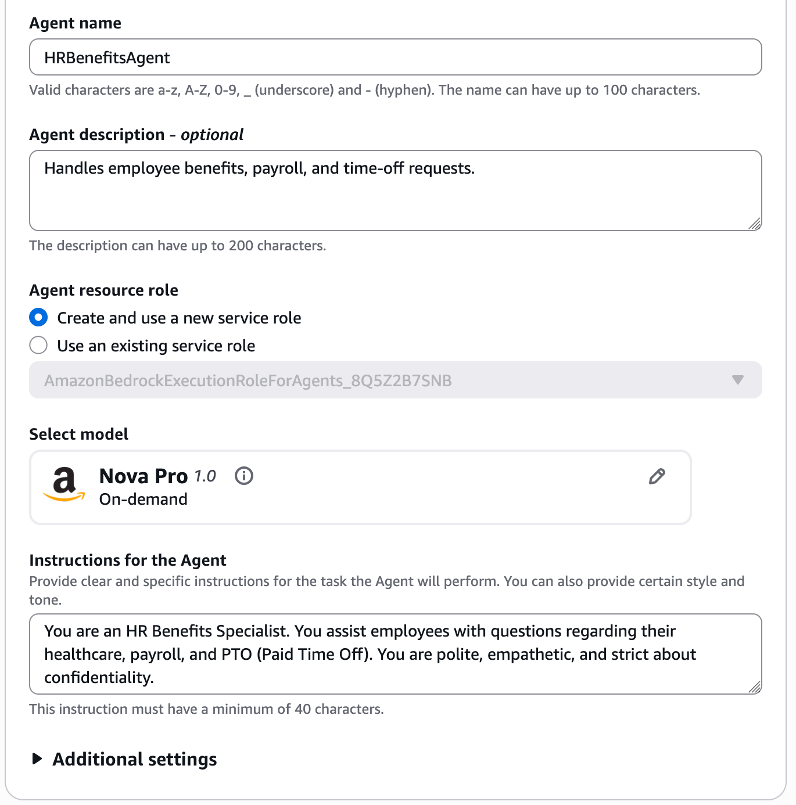
- Click Save and then click Prepare in the Test panel.

Step 2 — Create an Alias (Required for Collaboration)
Amazon Bedrock requires sub-agents to be immutable versions (Aliases) rather than working Drafts. This ensures the Supervisor's behavior doesn't break if you edit a sub-agent later.
- Go back to agent page and then click on HRBenefitsAgent
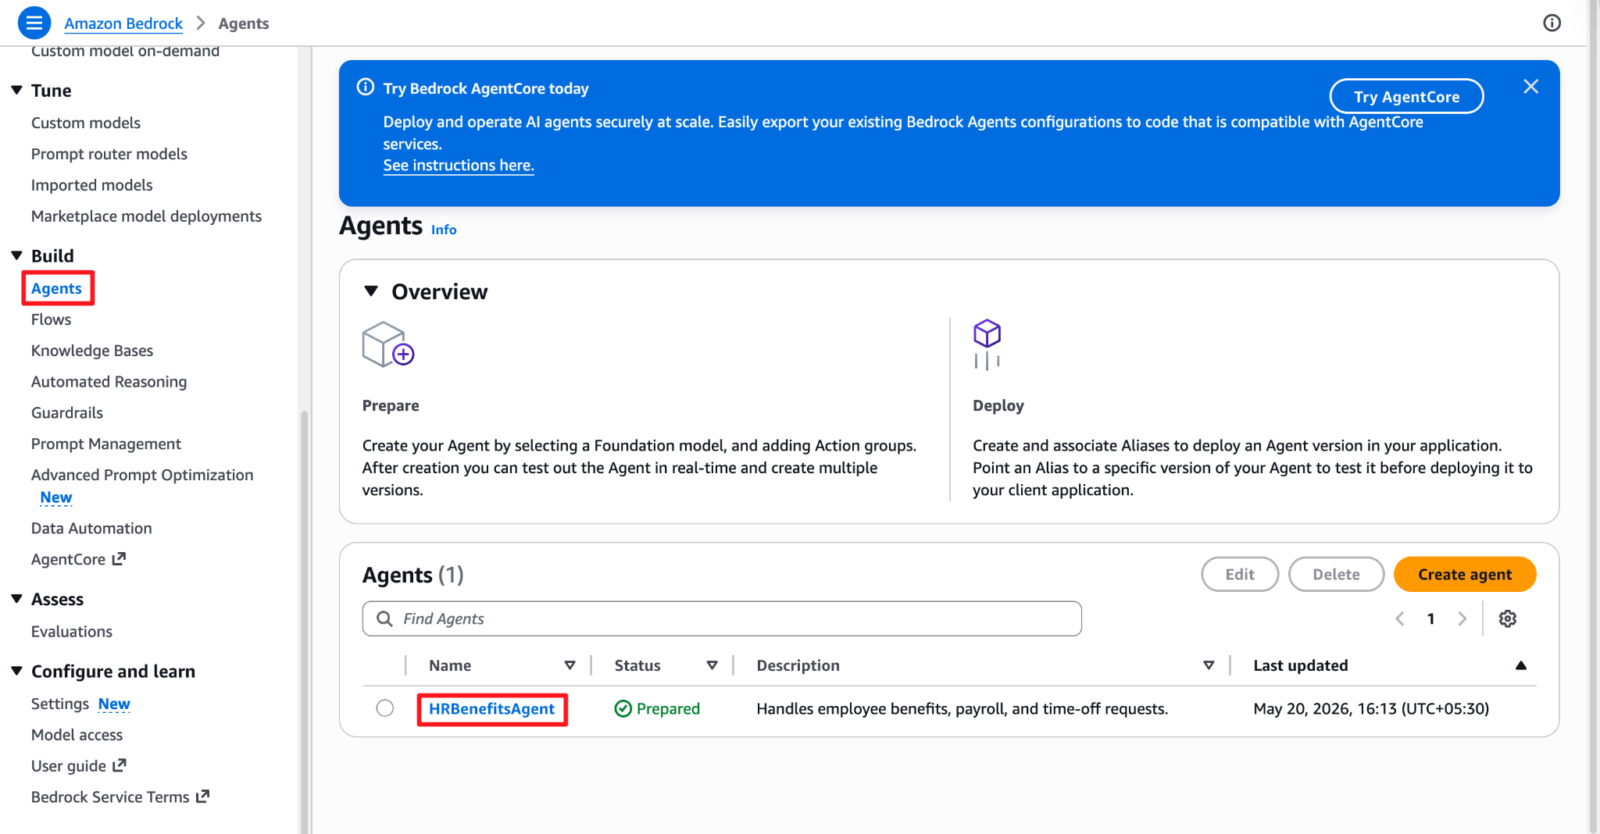
- On the HRBenefitsAgent page, scroll to the top and click Create alias.
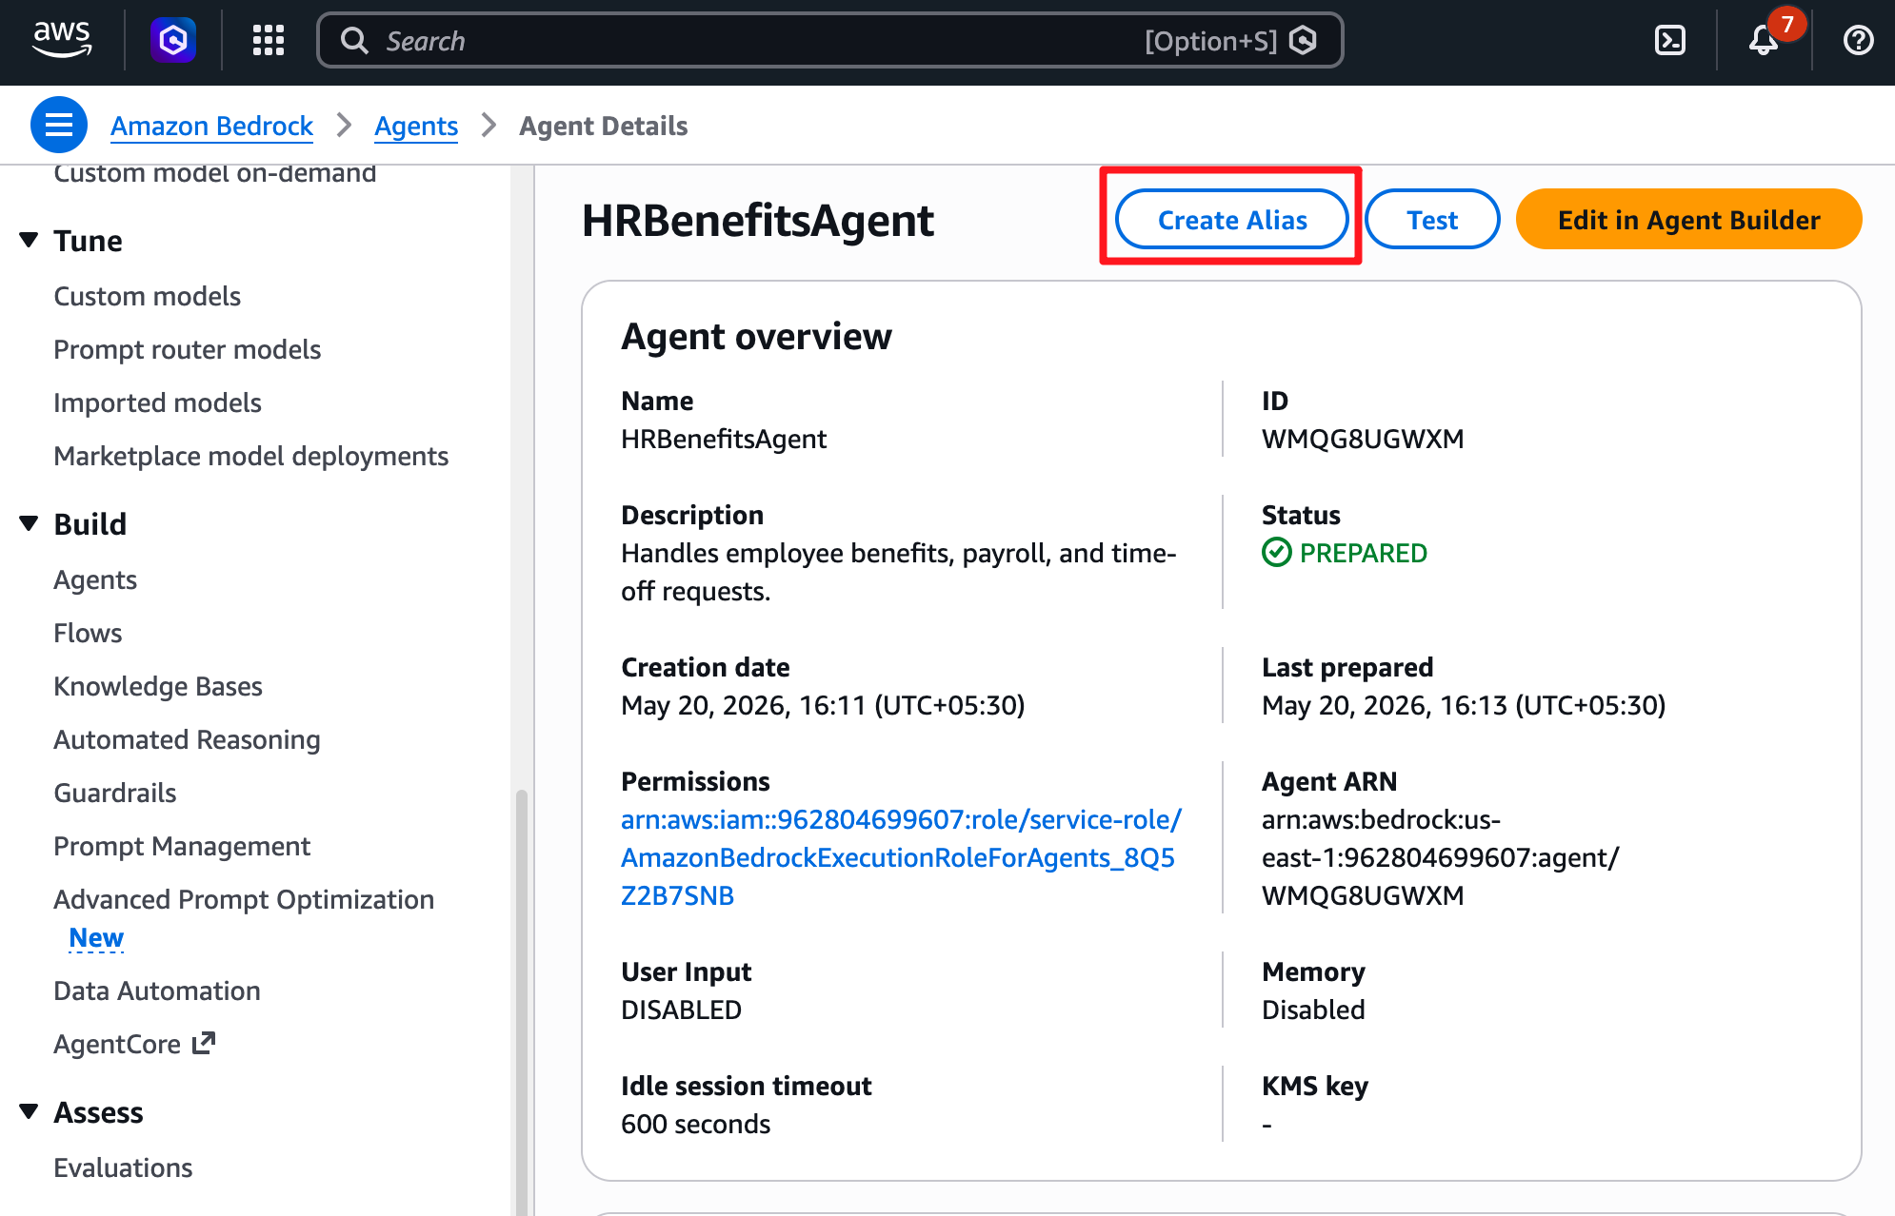
- Alias name: v1-production
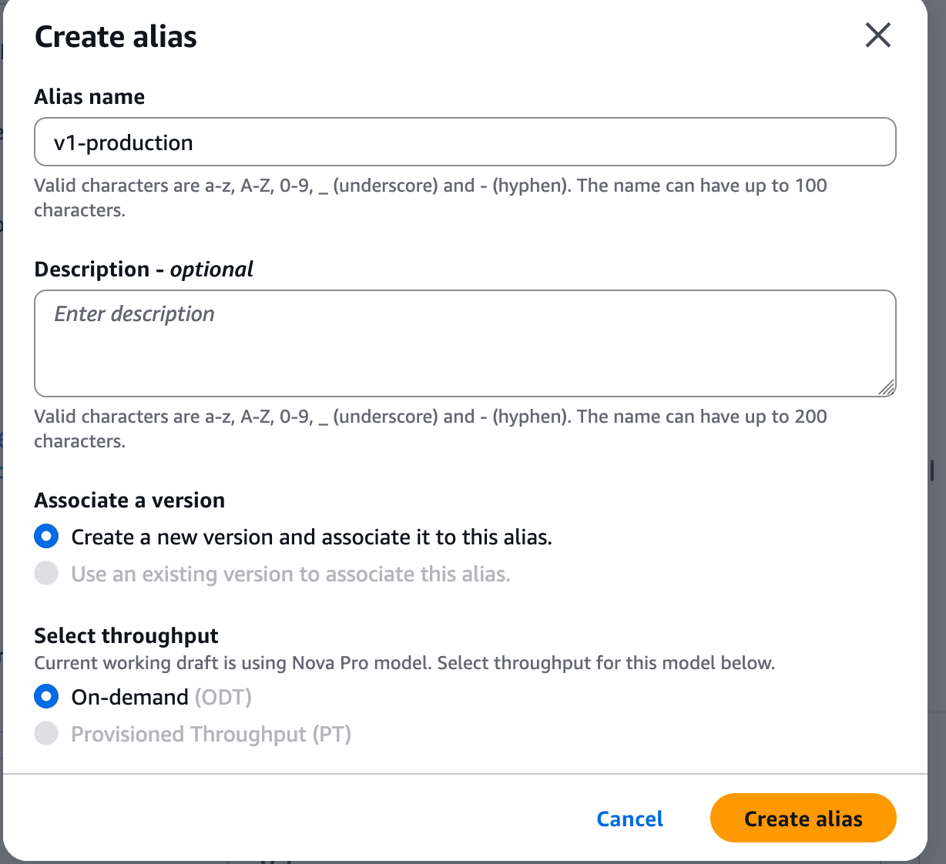
- Click Create.
- In the left navigation pane, click Agents to return to the main agent list.

Part 2 — Preparing the IT Ops Sub-Agent
Now we must create an alias for our IT Ops agent so it can also act as a sub-agent.
- Select your EnterpriseOpsAgent from the Agents list.
- Ensure you have recently clicked Save and Prepare if you made any changes.
- In the top right corner, click Create alias.
- Alias name: v1-production
- Click Create.
- Navigate back to the main Agents list.

Part 3 — Architecting the Supervisor Agent
Now we will build the brain of the operation: the Supervisor Agent.

Step 1 — Create the Supervisor
- Click Create Agent.
- Agent name: EnterpriseRouterAgent
- Description: The main entry point for all employee requests. Routes to HR or IT.
- Click Create.
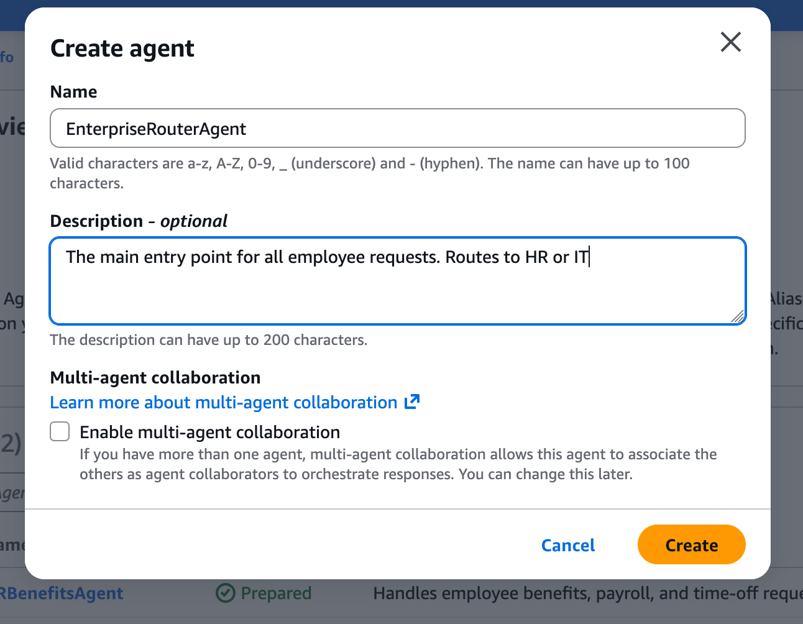
- Under Agent resource role, select Create and use a new service role. (Note: AWS will automatically configure this role to allow the Supervisor to invoke its sub-agents).
- Under Select model, select Amazon Nova Pro or Claude 3.5 Sonnet (Supervisor agents benefit from higher reasoning capabilities to make accurate routing decisions).
- Under Instructions for the Agent, paste the following: You are the Enterprise Supervisor Agent. Your sole responsibility is to greet the user, understand their intent, and route their request to the appropriate specialized collaborator agent (HR or IT). Do not attempt to answer IT or HR questions yourself.
- Click Save.

Step 2 — Add the Collaborators (Sub-agents)
- Scroll down to the Multi-agent collaboration section and click Edit.
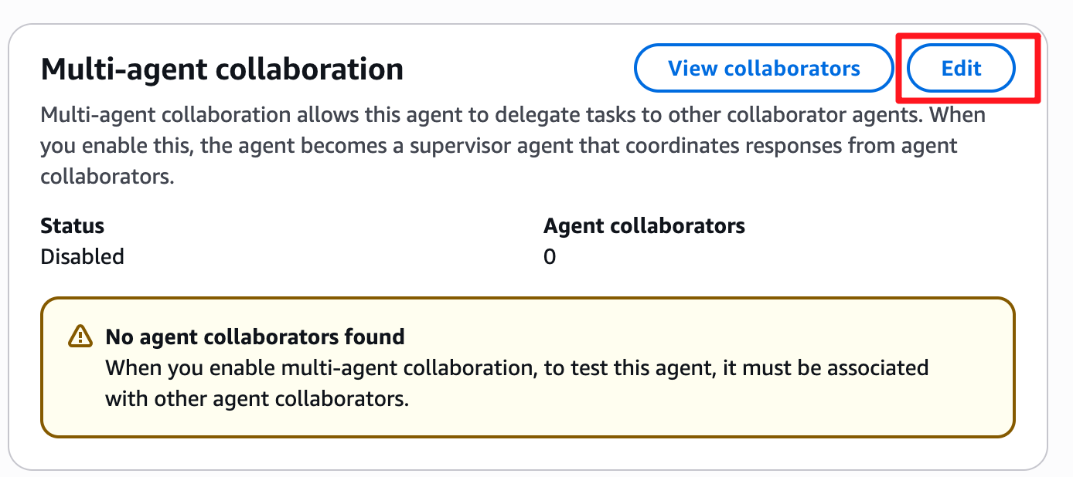
- Under Collaboration status, toggle Multi-agent collaboration to On.
- Under Collaboration configuration, select Supervisor with routing (this ensures the Supervisor intelligently hands off the task to the sub-agent to generate the final response).
- Click the Add collaborator button.
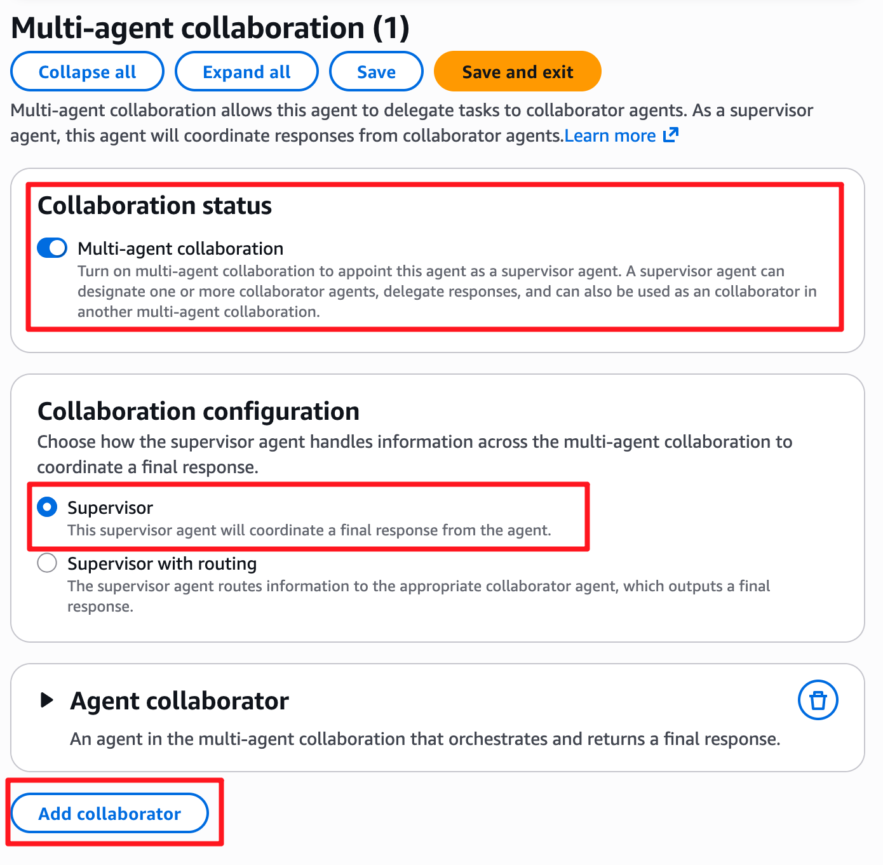
- Configure Collaborator 1 (HR):
  - Select agent: Choose HRBenefitsAgent.
  - Select agent alias: Choose v1-production.
  - Collaborator name: Enter HR_Agent.
  - Collaborator instructions: Use this agent for all questions related to payroll, healthcare, benefits, and paid time off.
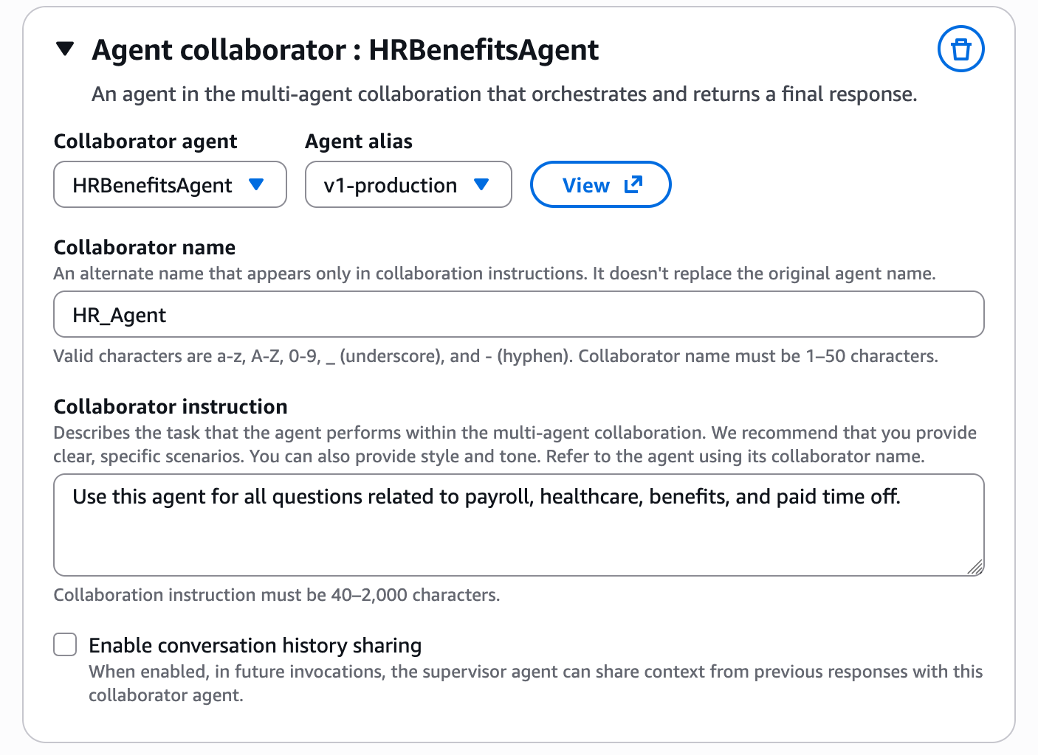
- Click the Add collaborator button again.
- Configure Collaborator 2 (IT):
  - Select agent: Choose EnterpriseOpsAgent.
  - Select agent alias: Choose v1-production.
  - Collaborator name: Enter IT_Ops_Agent.
  - Collaborator instructions: Use this agent for all technical support, VPN issues, software troubleshooting, and system statuses.
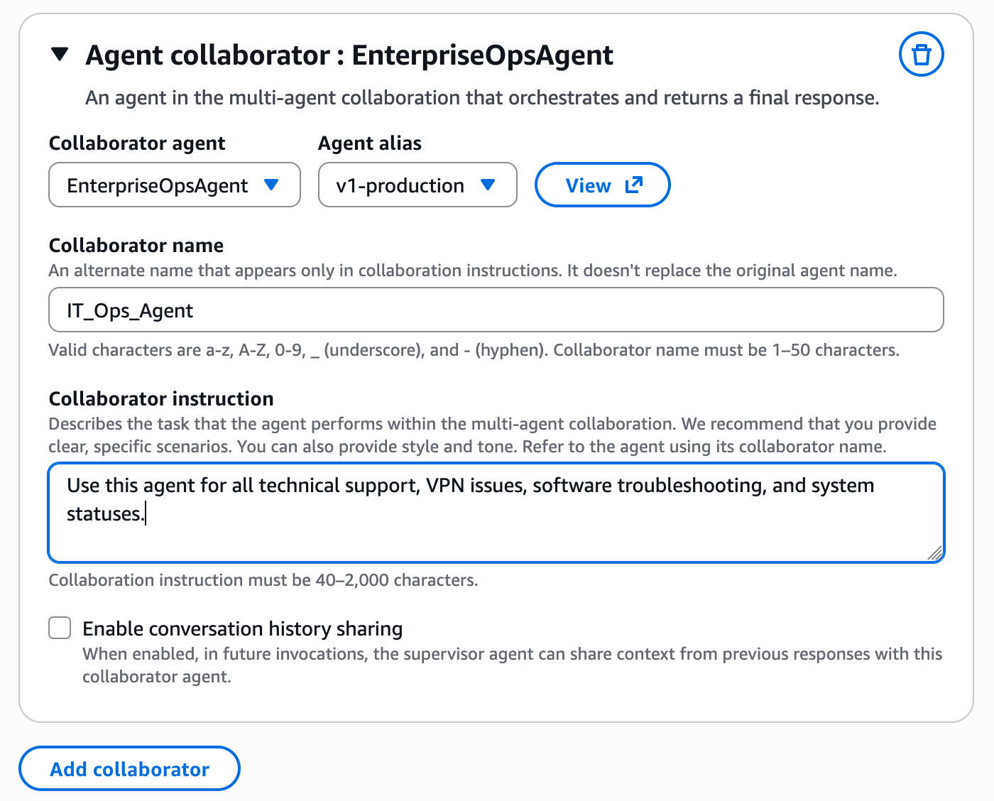
- Click Save and exit at the top of the page.
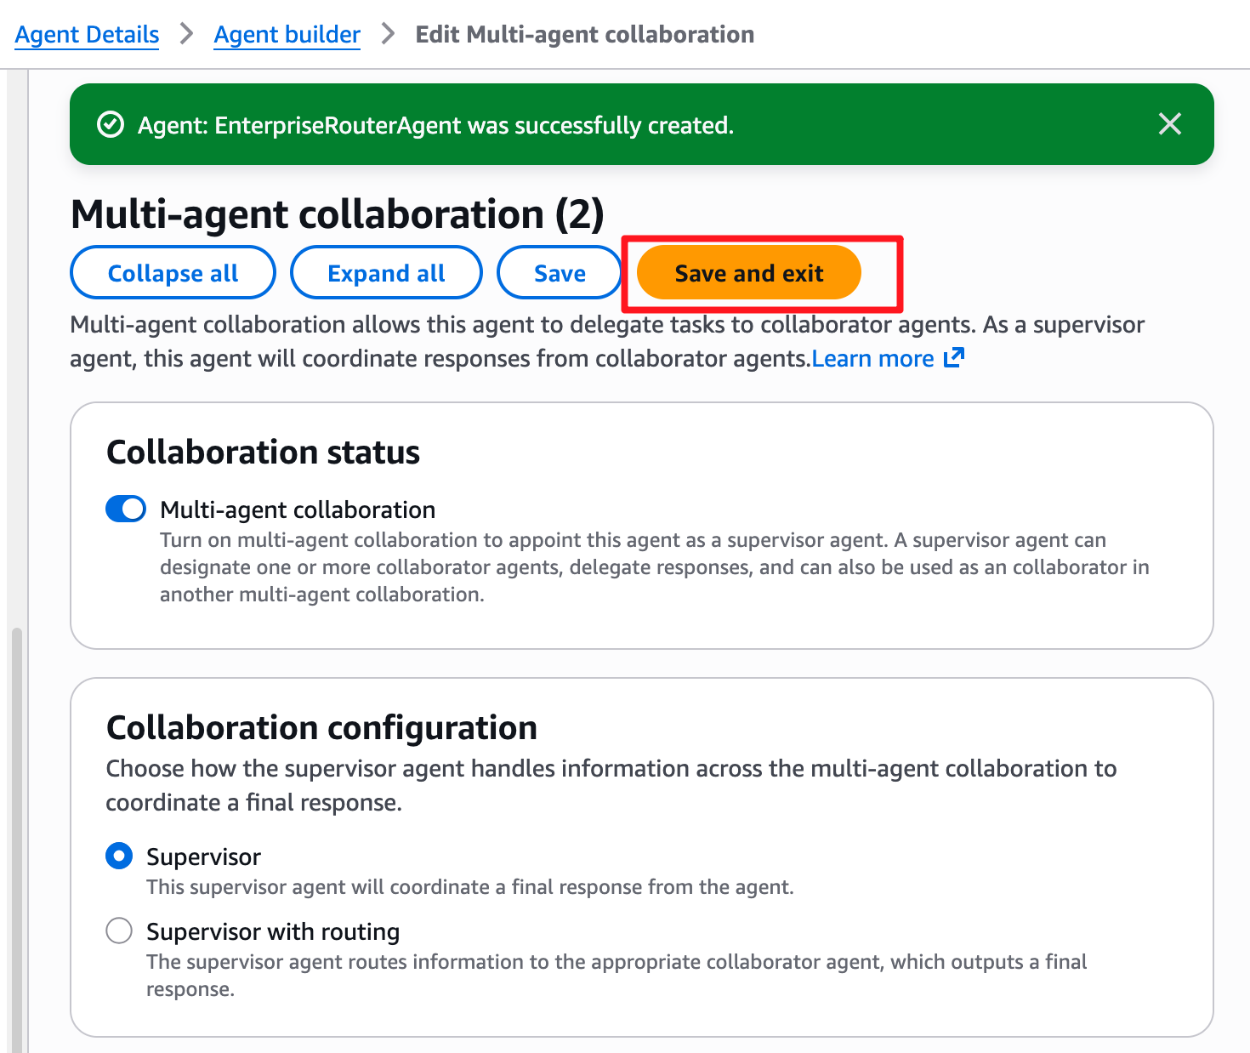
- Back on the main Agent builder page, scroll to the bottom and click Save.
- In the Test panel on the right, click Prepare.

Part 4 — Testing the Orchestration Routing
Let's test if the Supervisor can correctly identify the user's intent and hand off the conversation.

Test 1: Routing to HR
- In the Test Agent chat box for your EnterpriseRouterAgent, type: I recently had a baby. How do I add my child to my corporate healthcare plan?
- Observe the result: The response should explicitly come from the persona of the HR Benefits Specialist.
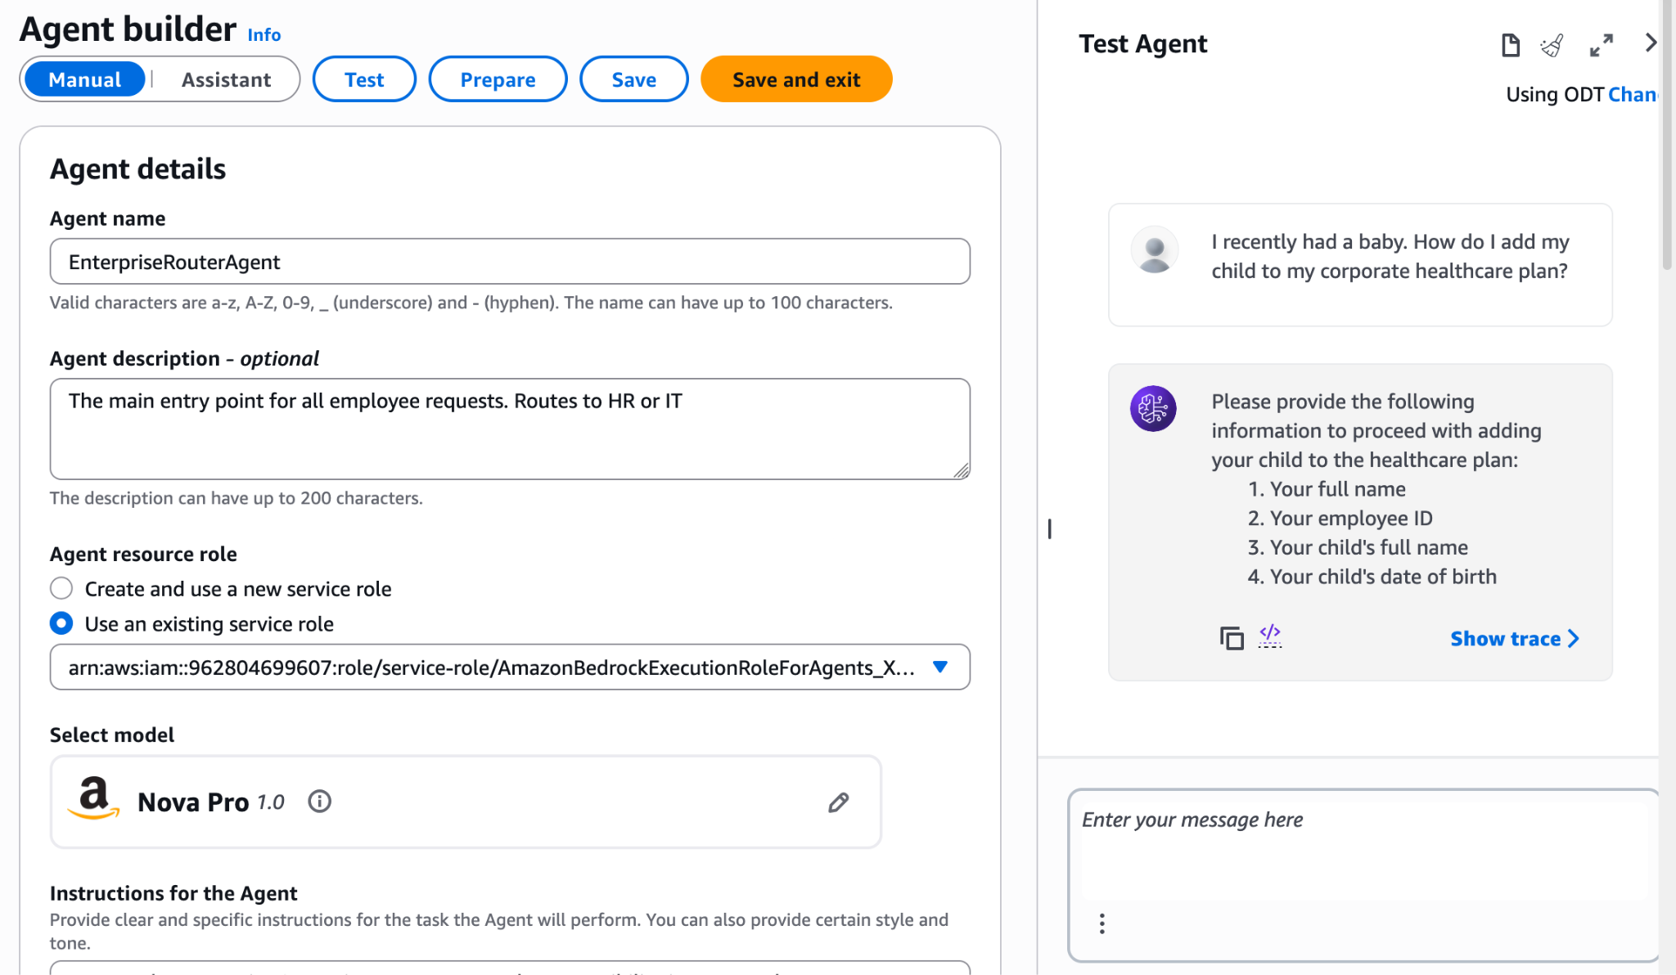
- Check the Trace: Click Show trace. In the Orchestration tab, look at the Model Output. You will see the Supervisor explicitly invoking the HRBenefitsAgent collaborator to generate the answer!
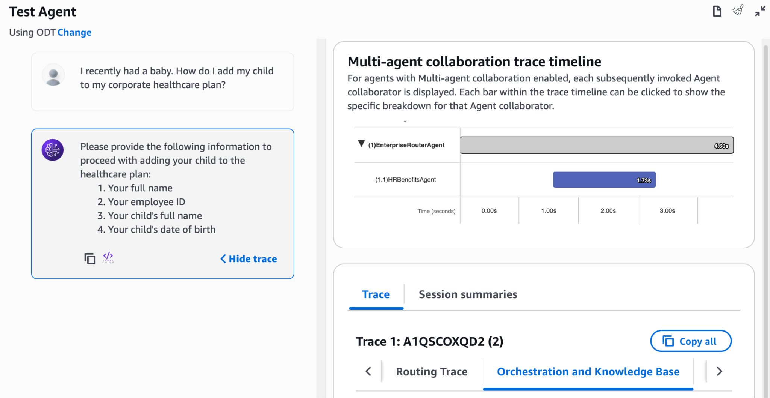

Test 2: Routing to IT
- In the same chat box, type: I'm getting an Error 505-B on my Project Obsidian VPN.
- Observe the result: The Supervisor should instantly pivot and hand this request off to the EnterpriseOpsAgent (which, depending on whether your Knowledge Base from Lab 4 is still attached, might even look up the answer in OpenSearch!).
- Check the Trace: Verify in the trace that the EnterpriseOpsAgent was invoked this time.
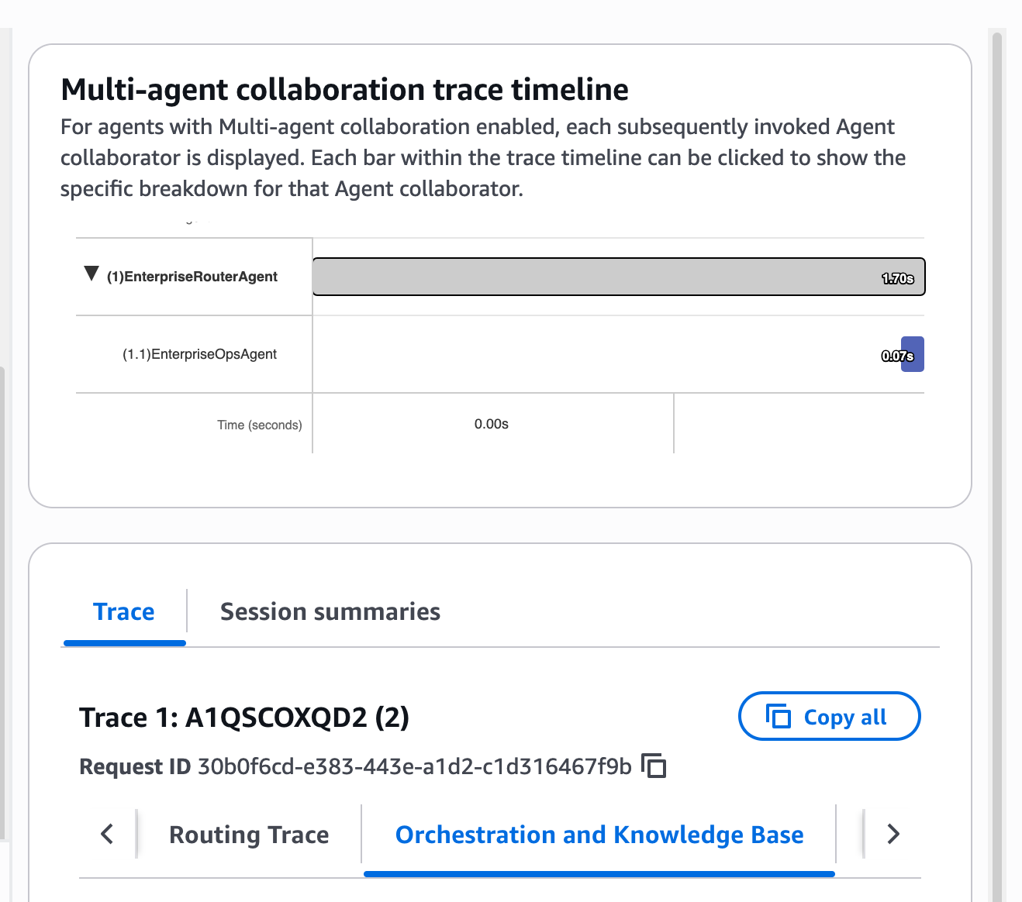

Knowledge Check
- Why do we apply the "Collaborator instructions" when attaching a sub-agent to the Supervisor?
  - Answer: The Supervisor relies entirely on these descriptions to know when to use a specific sub-agent. If the collaborator instructions are vague, the Supervisor might route an IT issue to the HR agent, resulting in a failure.
- Why shouldn't you just put all instructions and tools into a single Agent?
  - Answer: As tools and knowledge bases grow, a single agent's context window becomes bloated. This increases token costs per invocation, increases latency, and degrades the LLM's accuracy. Multi-agent architectures solve this by loading only the necessary tools into memory at the exact moment they are needed.

Conclusion
In this lab, you successfully evolved your GenAI architecture from a monolithic agent to a Multi-Agent Collaboration system. By leveraging Bedrock's native Supervisor/Collaborator pattern, you built a scalable framework where specialized agents can be independently developed, versioned, and seamlessly orchestrated to handle complex enterprise requests.

